1. Family offices will have commodities, Forex, Bonds, Crypto along with World stocks (US, UK, Japan, HK, Singapore etc). So in my view, we need to implement. However this is a critical decision for the following reasons.
1.1. Crypto is wild as it runs 24*7.
1.2.It is easy to do API calls and show the price alone. However our uniqueness is show additional data like, Circulating market cap, Token Turnover, Trading Volume, Financial data. Example - https://tokenterminal.com/explorer/projects/aave/financial-statement
https://tokenterminal.com/pricing - For API data
1.b Charting for Crypto (TV Widget is ok)
2. When i click on US Markets or DE, following are the observations. I know these are very easy to correct or may be cosmetic
2.1. Top gainers and losers are showing as INR, should be in respective currency.
2.2. News should be populated according to the country
2.3.Events should be populated according to the country
3. Here is what i feel, we need to change in the overall homepage.
3.1 A World view which should consist of World Indices (India, US,UK, Japan, HK, Singapore, Commodities, Crypto, Forex, Bonds)
Examples are as follows
https://finviz.com/map.ashx?t=geo
https://finviz.com/map.ashx?t=cap
https://finviz.com/map.ashx?t=crypto
3.2 User should just get a glimpse of what is happening across the globe from homepage itself,
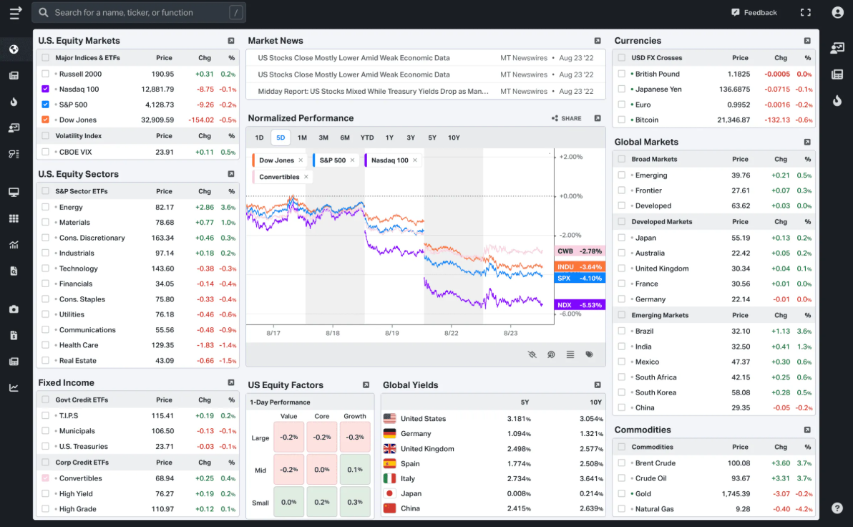
3.3 Very IMP - World Economic calender and events which effect the price, money supply, jobs. Trading view and below website has the API / Widget for that.
Examples are
https://tradingeconomics.com/calendar
https://finviz.com/calendar/economic
3.4 Major news section in finviz.com homepage is very unique and extremely informative. The beauty of it is user doesnt need to move out of the page. as soon user scrolls to the stock, a simple AI analysis of the stock price is shown and it is very crisp information.
Reference - Please refer to the below URL. Refer to the section below the heatmap, right there is the major news section.
https://finviz.com/
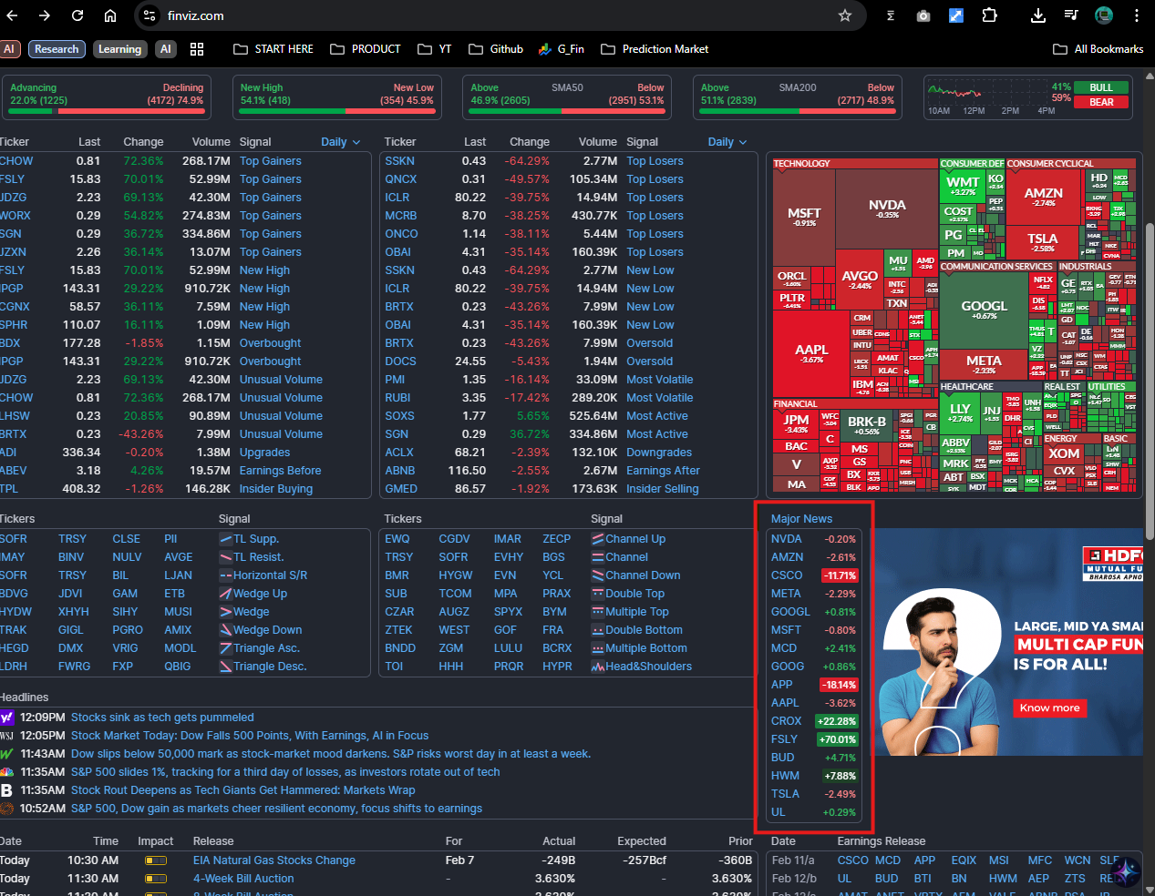
3.5 The Finviz-style Heatmap (Tree Maps):
What it does: Uses nested rectangles to represent sector and industry size, with colors indicating price performance.
The Upgrade for AI: Instead of just price, allow the heatmap to toggle between AI Sentiment Scores, Relative Strength, or Valuation Gaps.

4. Each stock should have a technical analysis section. Which is available as a widget in tradingview.
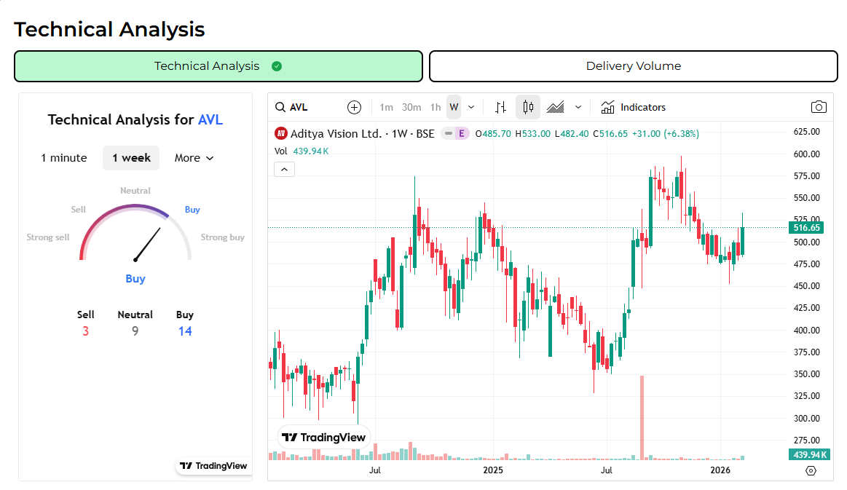

5. Portfolio
Very important for family offices, PMS and Retail. There is a huge role of AI here considering
the Macros and Economic conditions. This is a big topic and we need to have this as part of demo2. We also need to take feedback.
5.1 Plotting Risk vs. Return or P/E Ratio vs. Growth. For Family Offices, visualizing the "Efficient Frontier" of their current portfolio versus an AI-optimized version is a high-value UI feature.
5.2 Sankey Diagrams for Cash Flow:
Perfect for PMS and Family Offices to visualize how revenue flows through a company (Income $\rightarrow$ Operating Expense $\rightarrow$ Net Profit) or how a portfolio’s dividends are being reinvested.
5.3 Portfolio Visualizer. - A heat-mapped grid showing how assets move in relation to one another. AI can highlight "hidden correlations" that emerge during market stress, providing a "Stress Test" visualization.
5.4 Multi-level sector exposure. A center circle for the total portfolio, an outer ring for sectors, and a further ring for individual holdings. This is superior to a standard pie chart for complex PMS portfolios.

Audience | Visual Priority | UX Requirement
Retail Investors | Tree Maps & Sentiment Gauges | Simplicity. "Is the light green or red?"
PMS Managers | Correlation Matrices & Style Boxes | Comparison. "How does this stock change my beta?"
Family Offices | Sankey Diagrams & Risk Clouds | Preservation. "What is my maximum drawdown risk?"

